**Q1**

**Landing Page after login:**

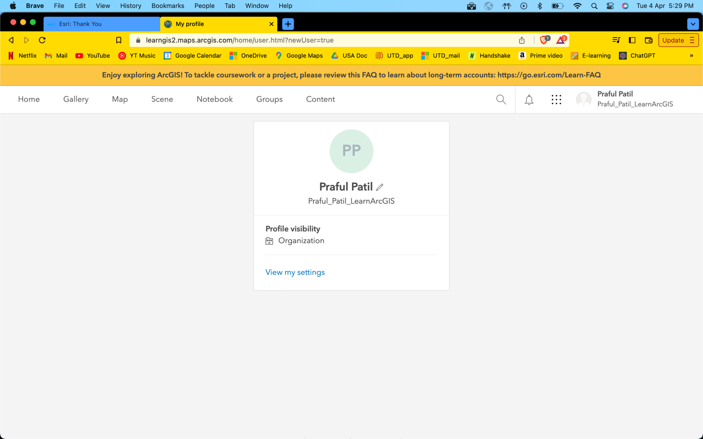

**Business Analyst Homepage:**

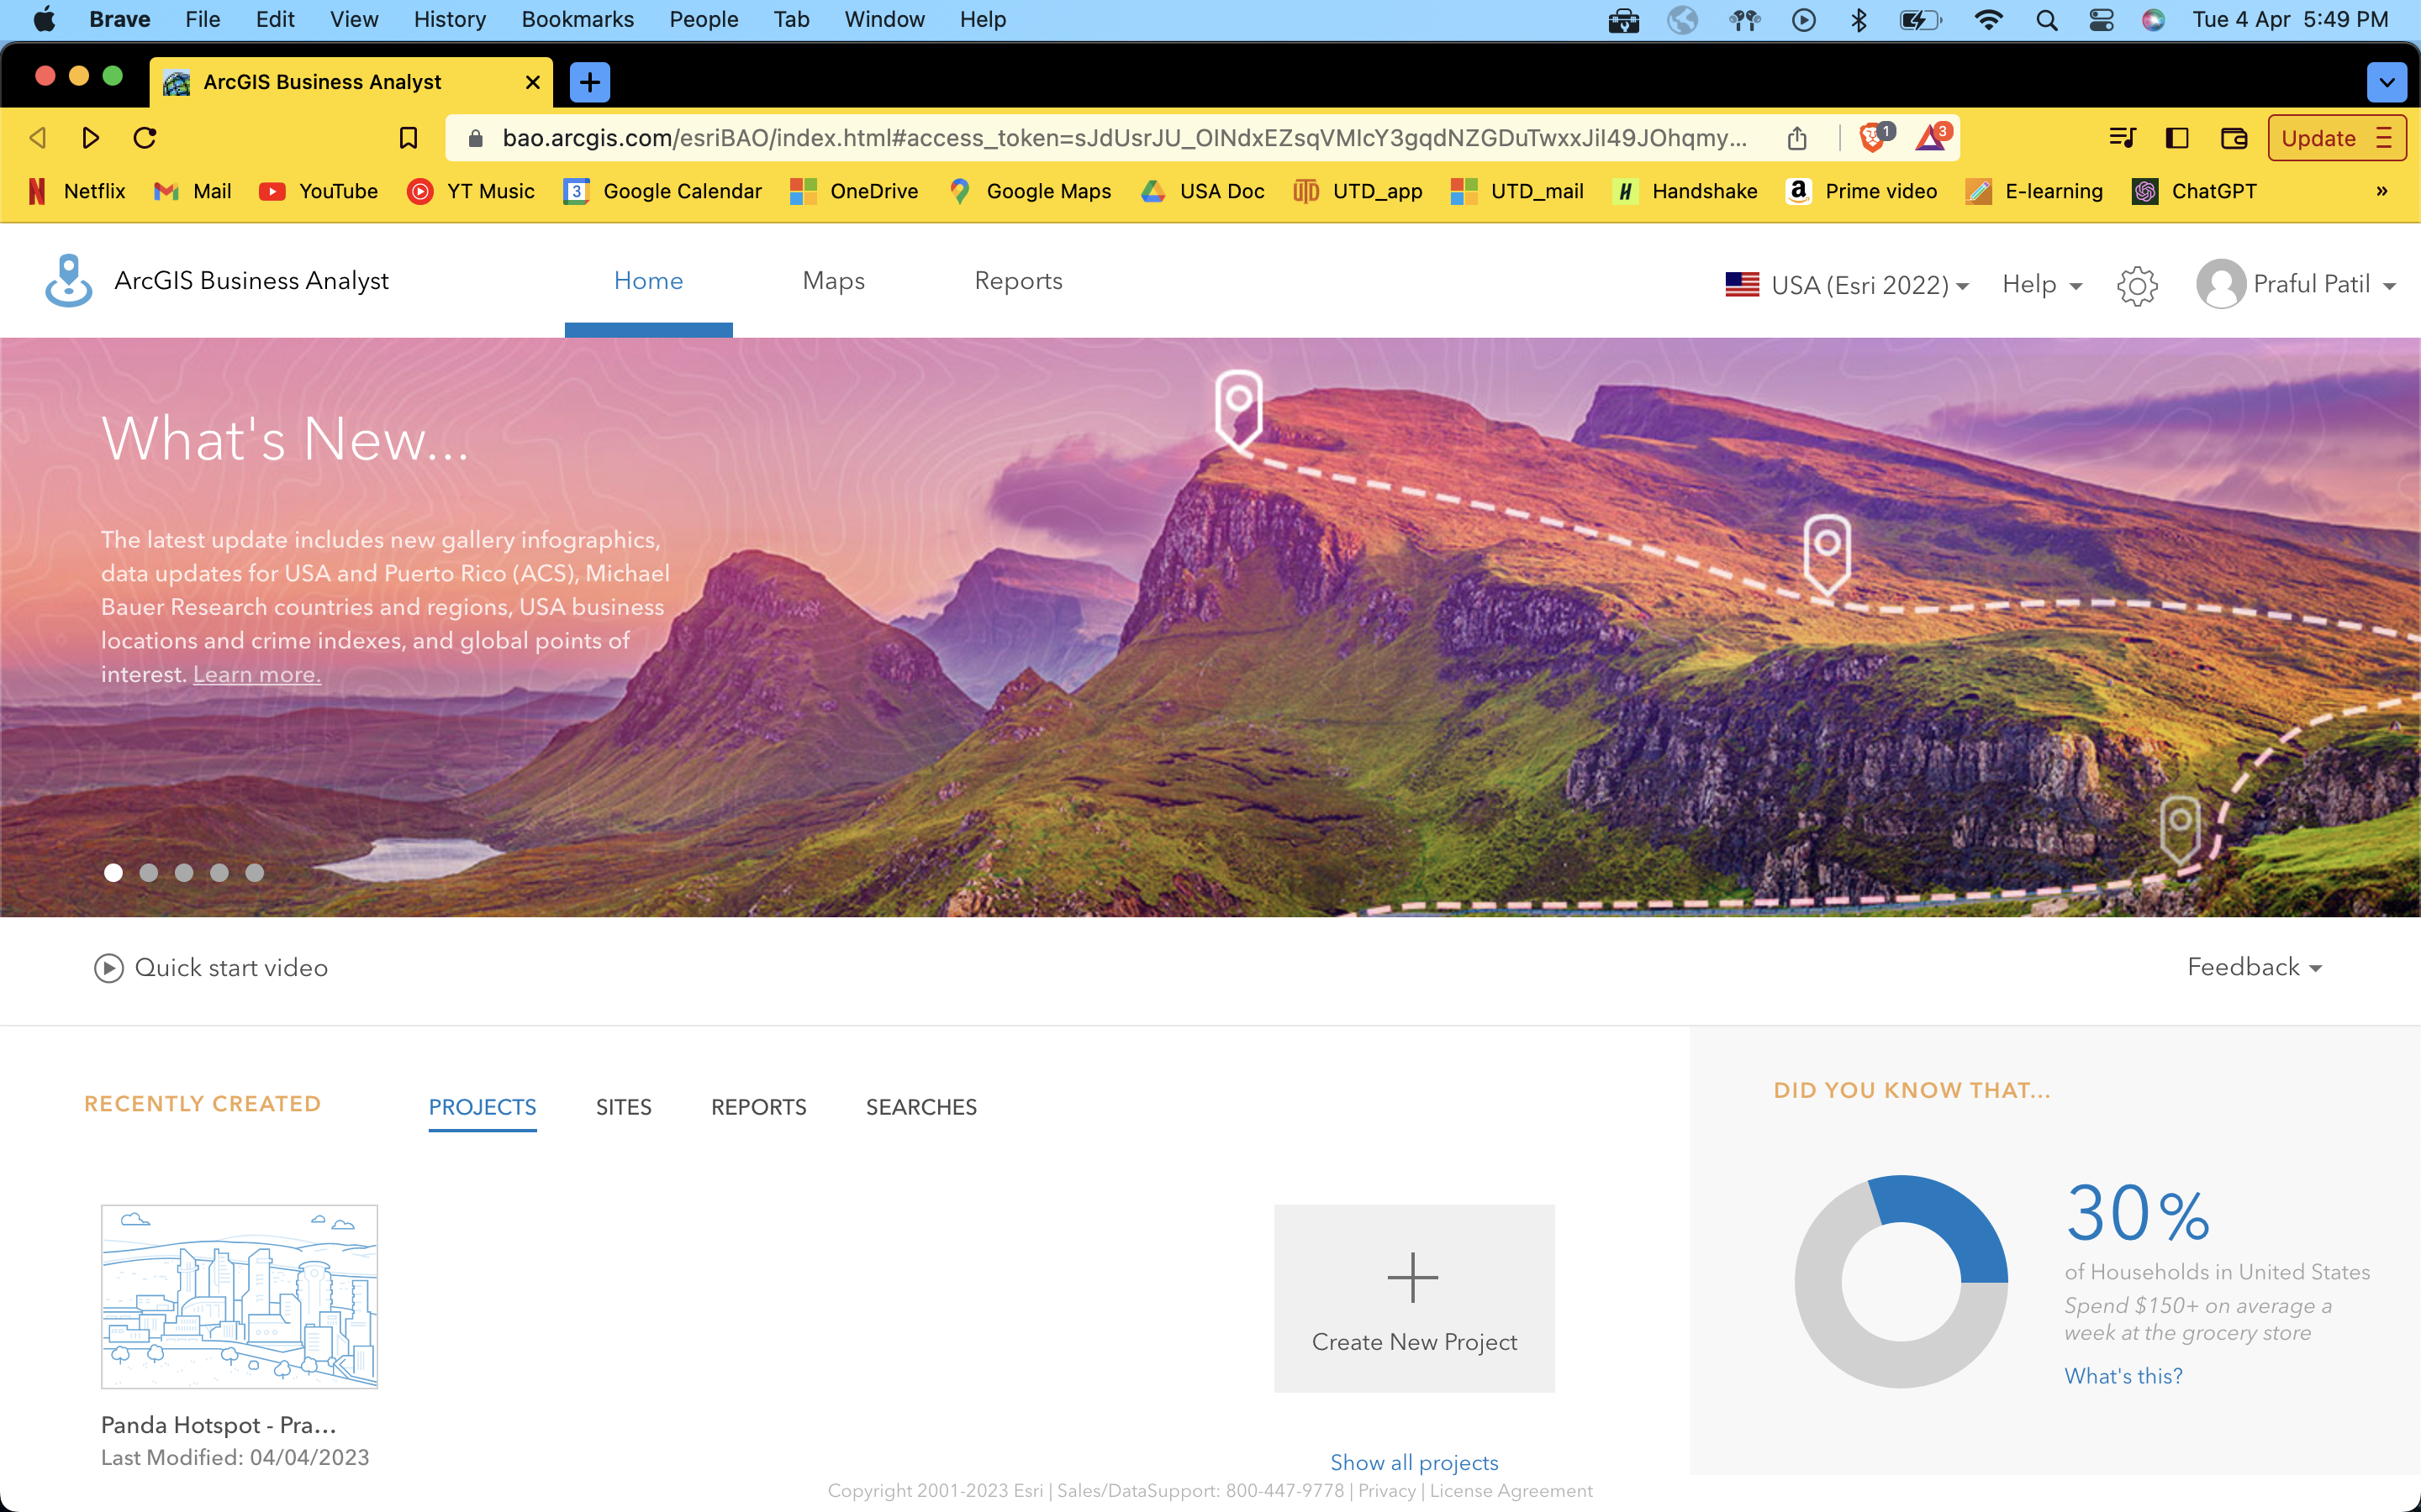

**Q2**

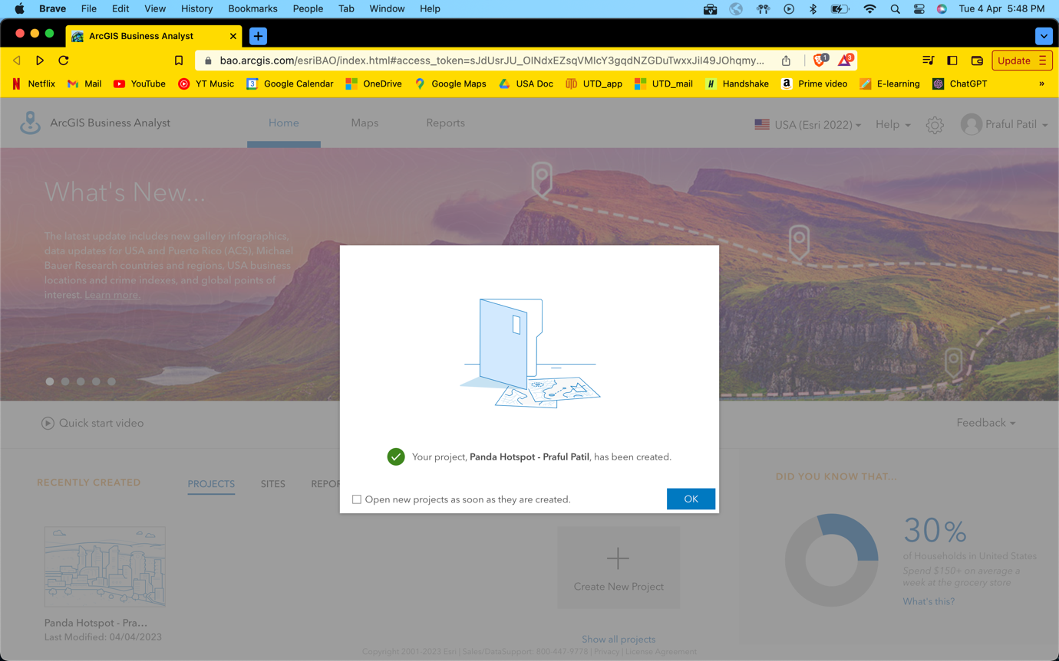**Q3**

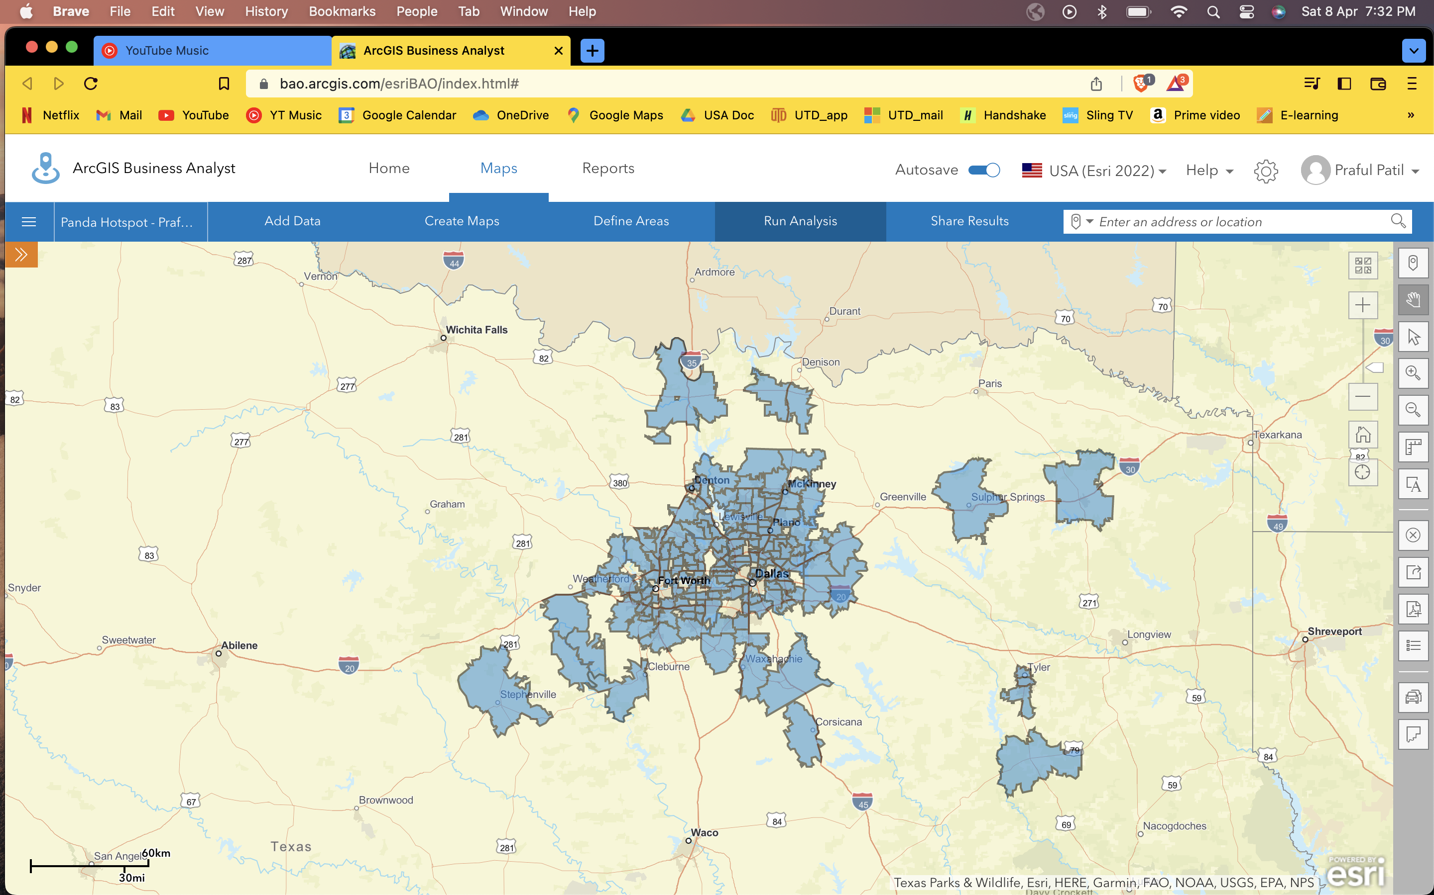

**Q4**

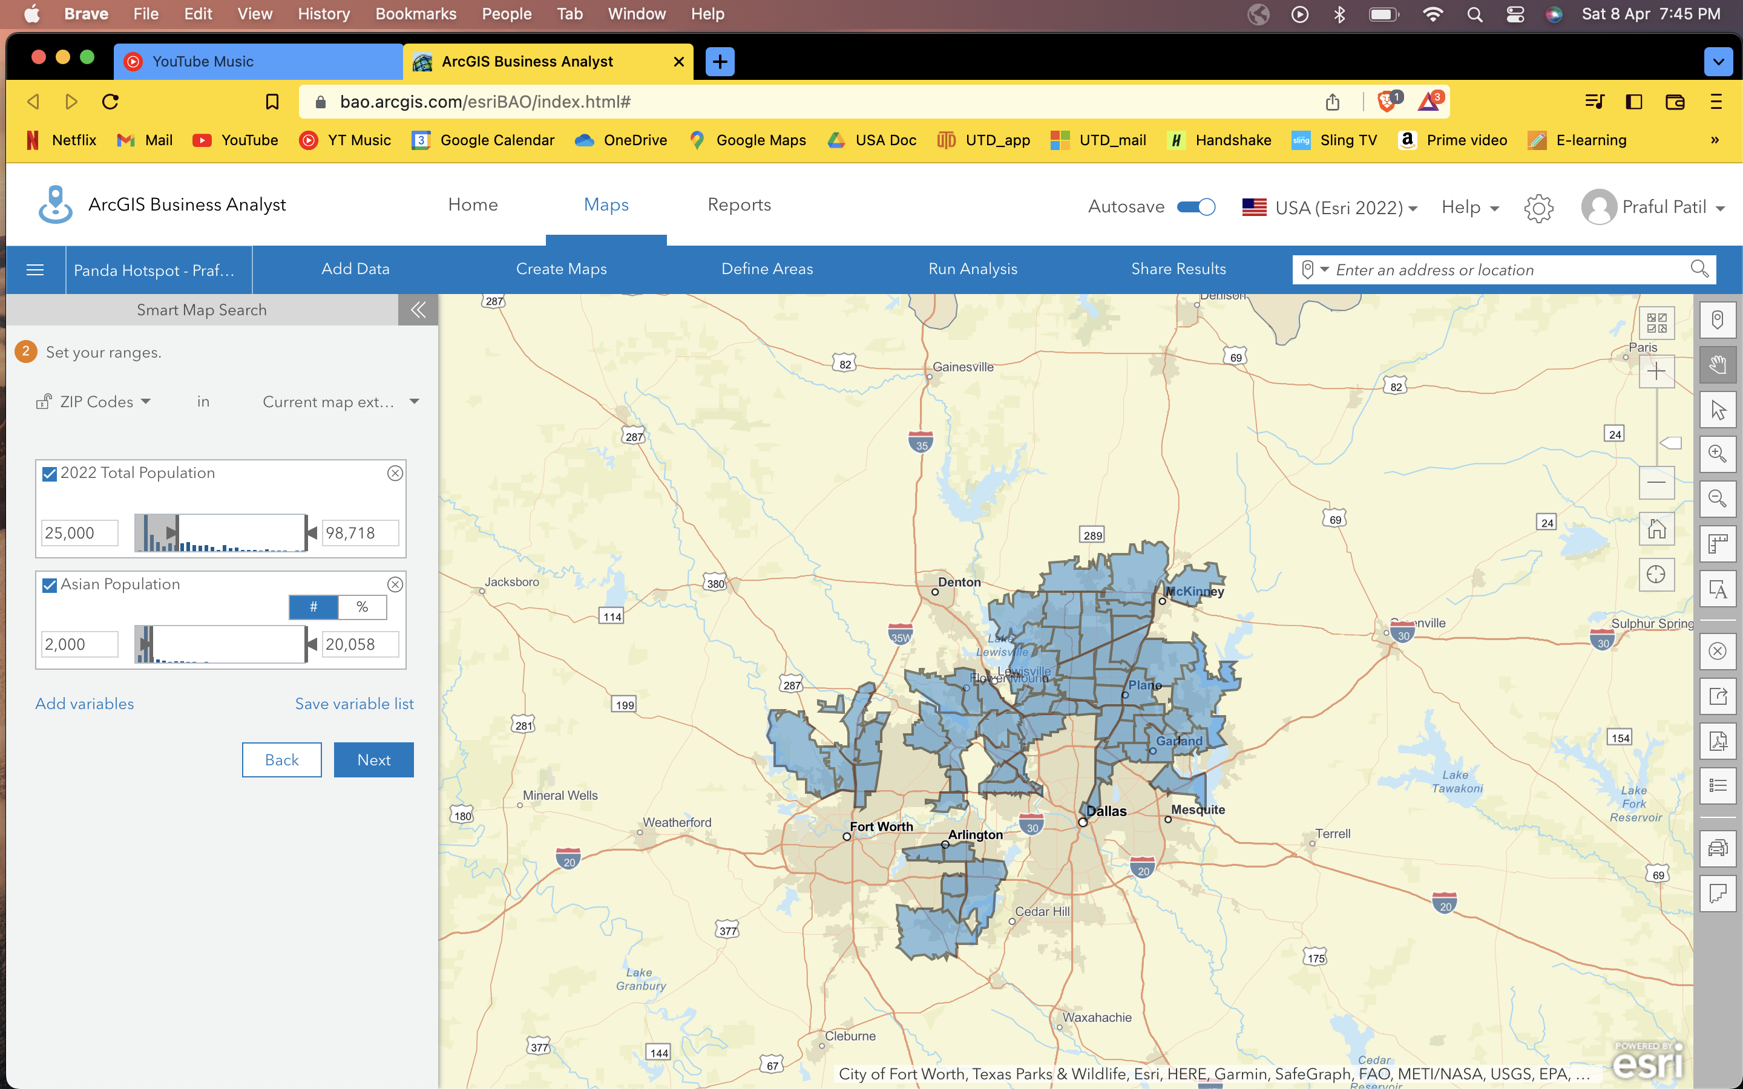

**Q5**

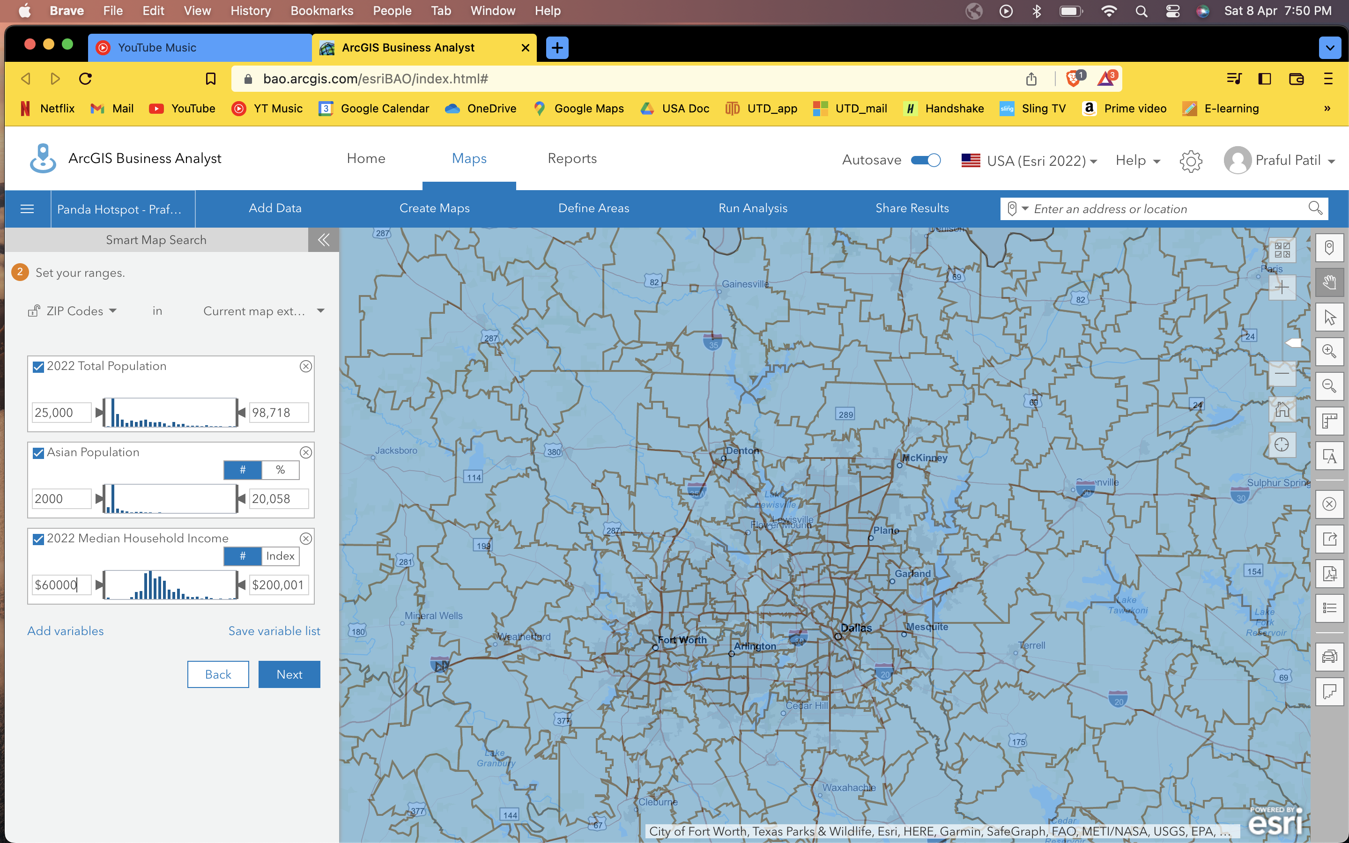

**Q6**

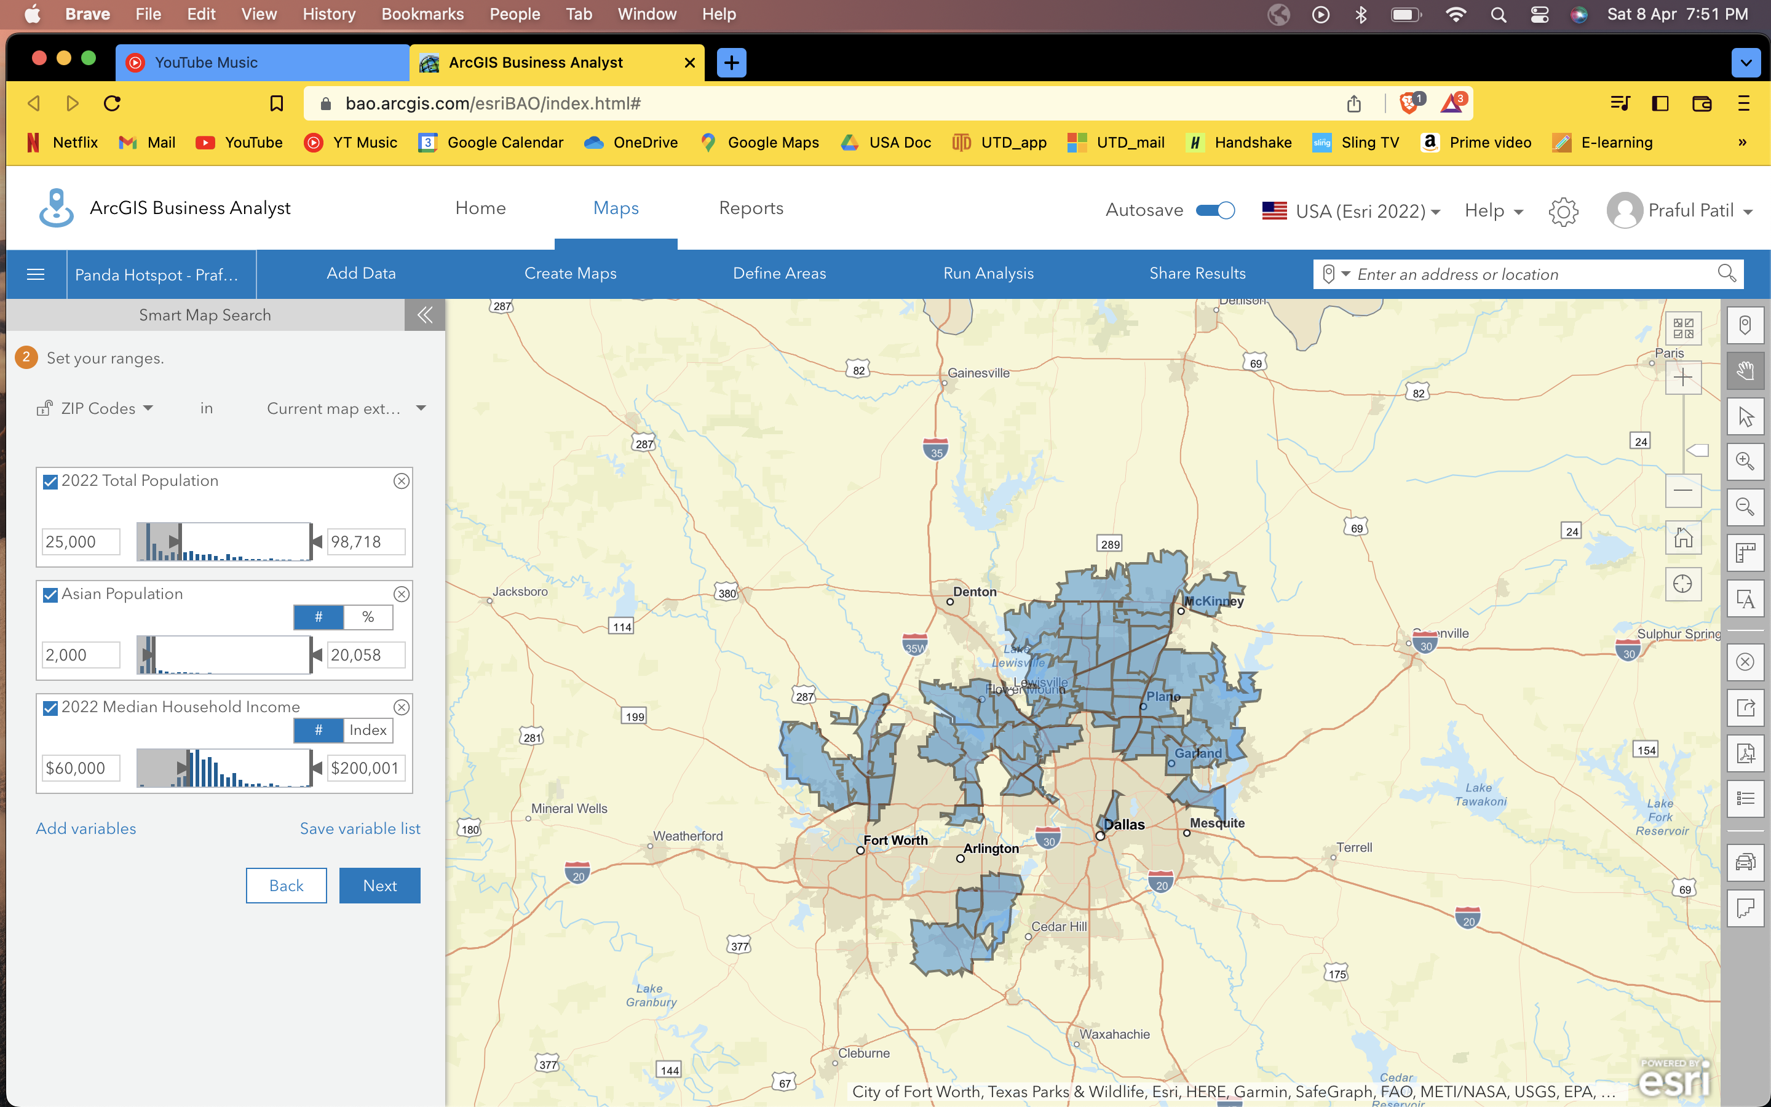

**Q7**

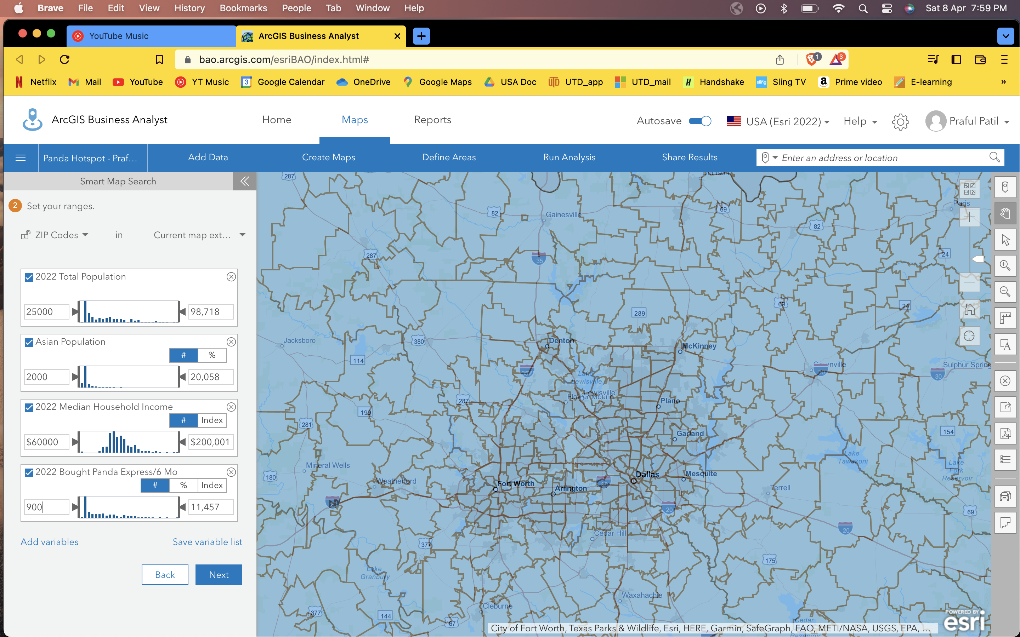

**Q8**

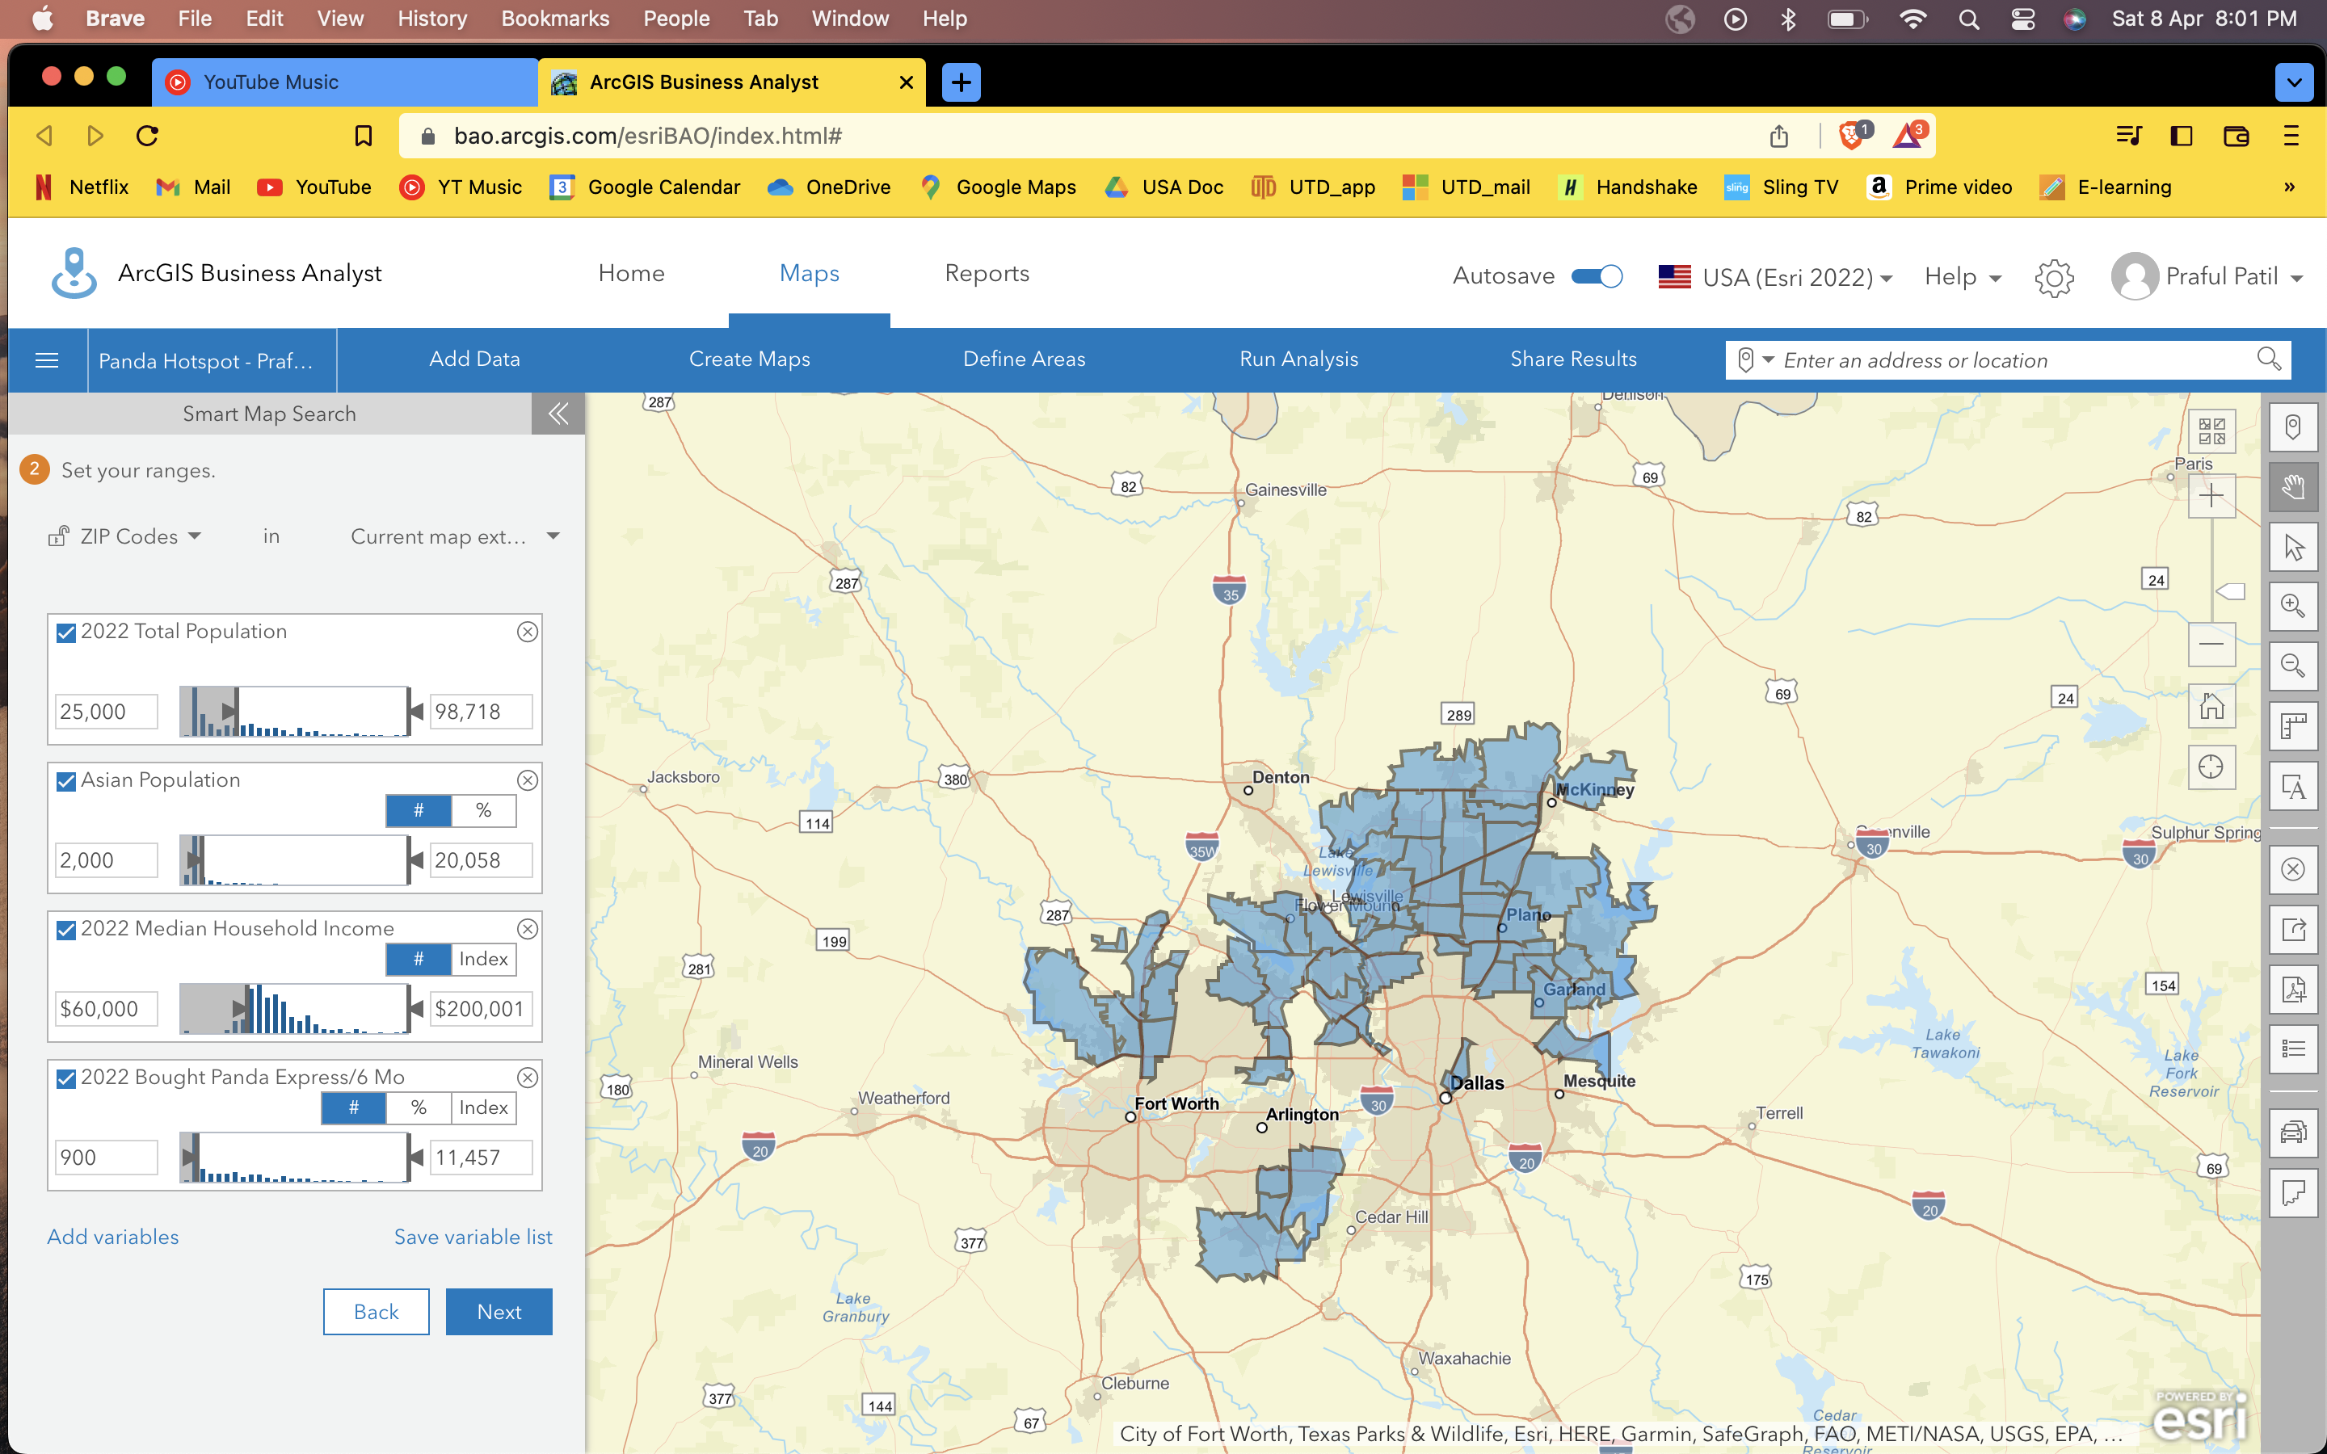

**Q9**

**Customer Profile 1:**

2021 Boomburbs (1C) Tapestry Adult Population (Esri)

**Customer Profile 2:**

2021 Laptops and Lattes (3A) Tapestry Adult Population (Esri)

**Customer Profile 3:**

2021 Trendsetters (3C) Tapestry Adult Population (Esri)

**Customer Profile 4:**

2021 Up and Coming Families (7A) Tapestry Adult Population (Esri)

**Customer Profile 5:**

2021 Young and Restless (11B) Tapestry Adult Population (Esri)

**Q10**

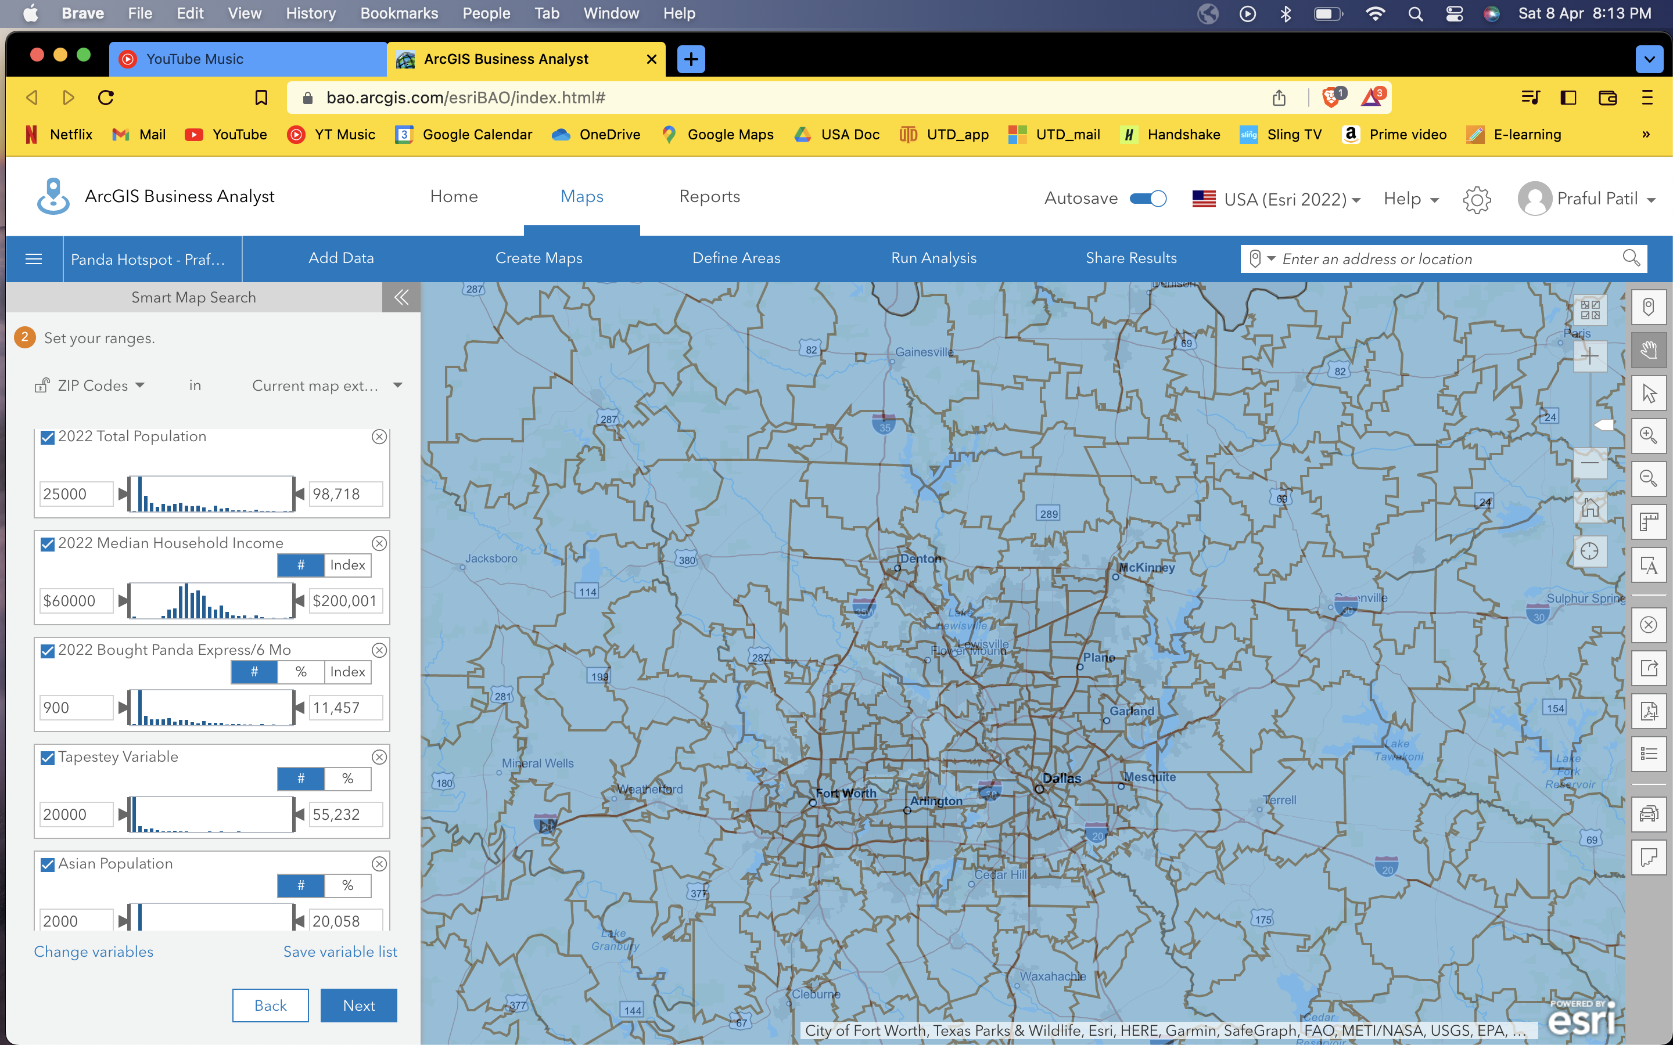

**Q11**

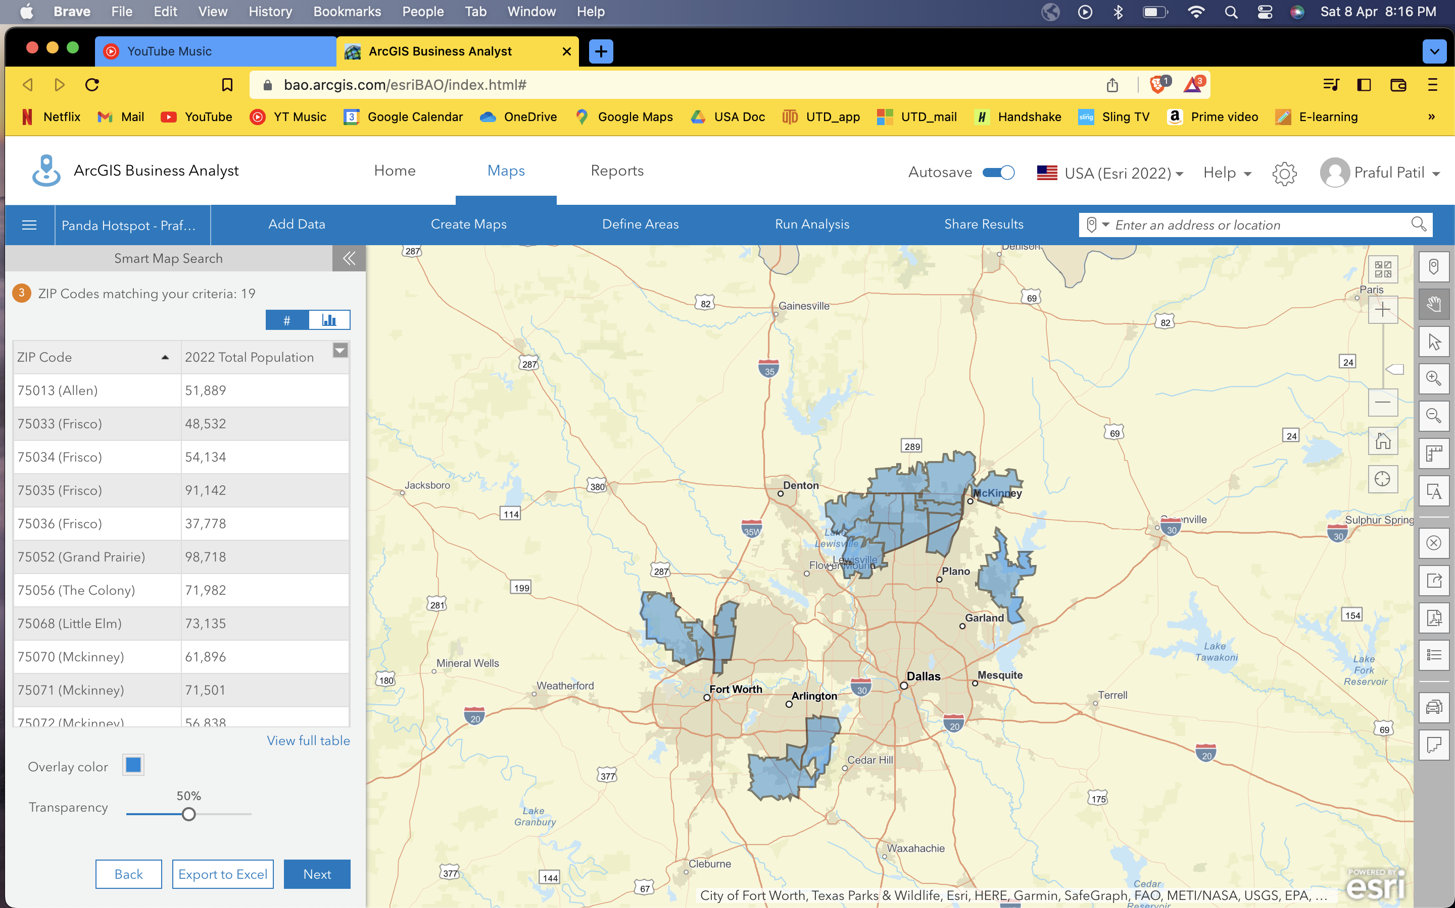

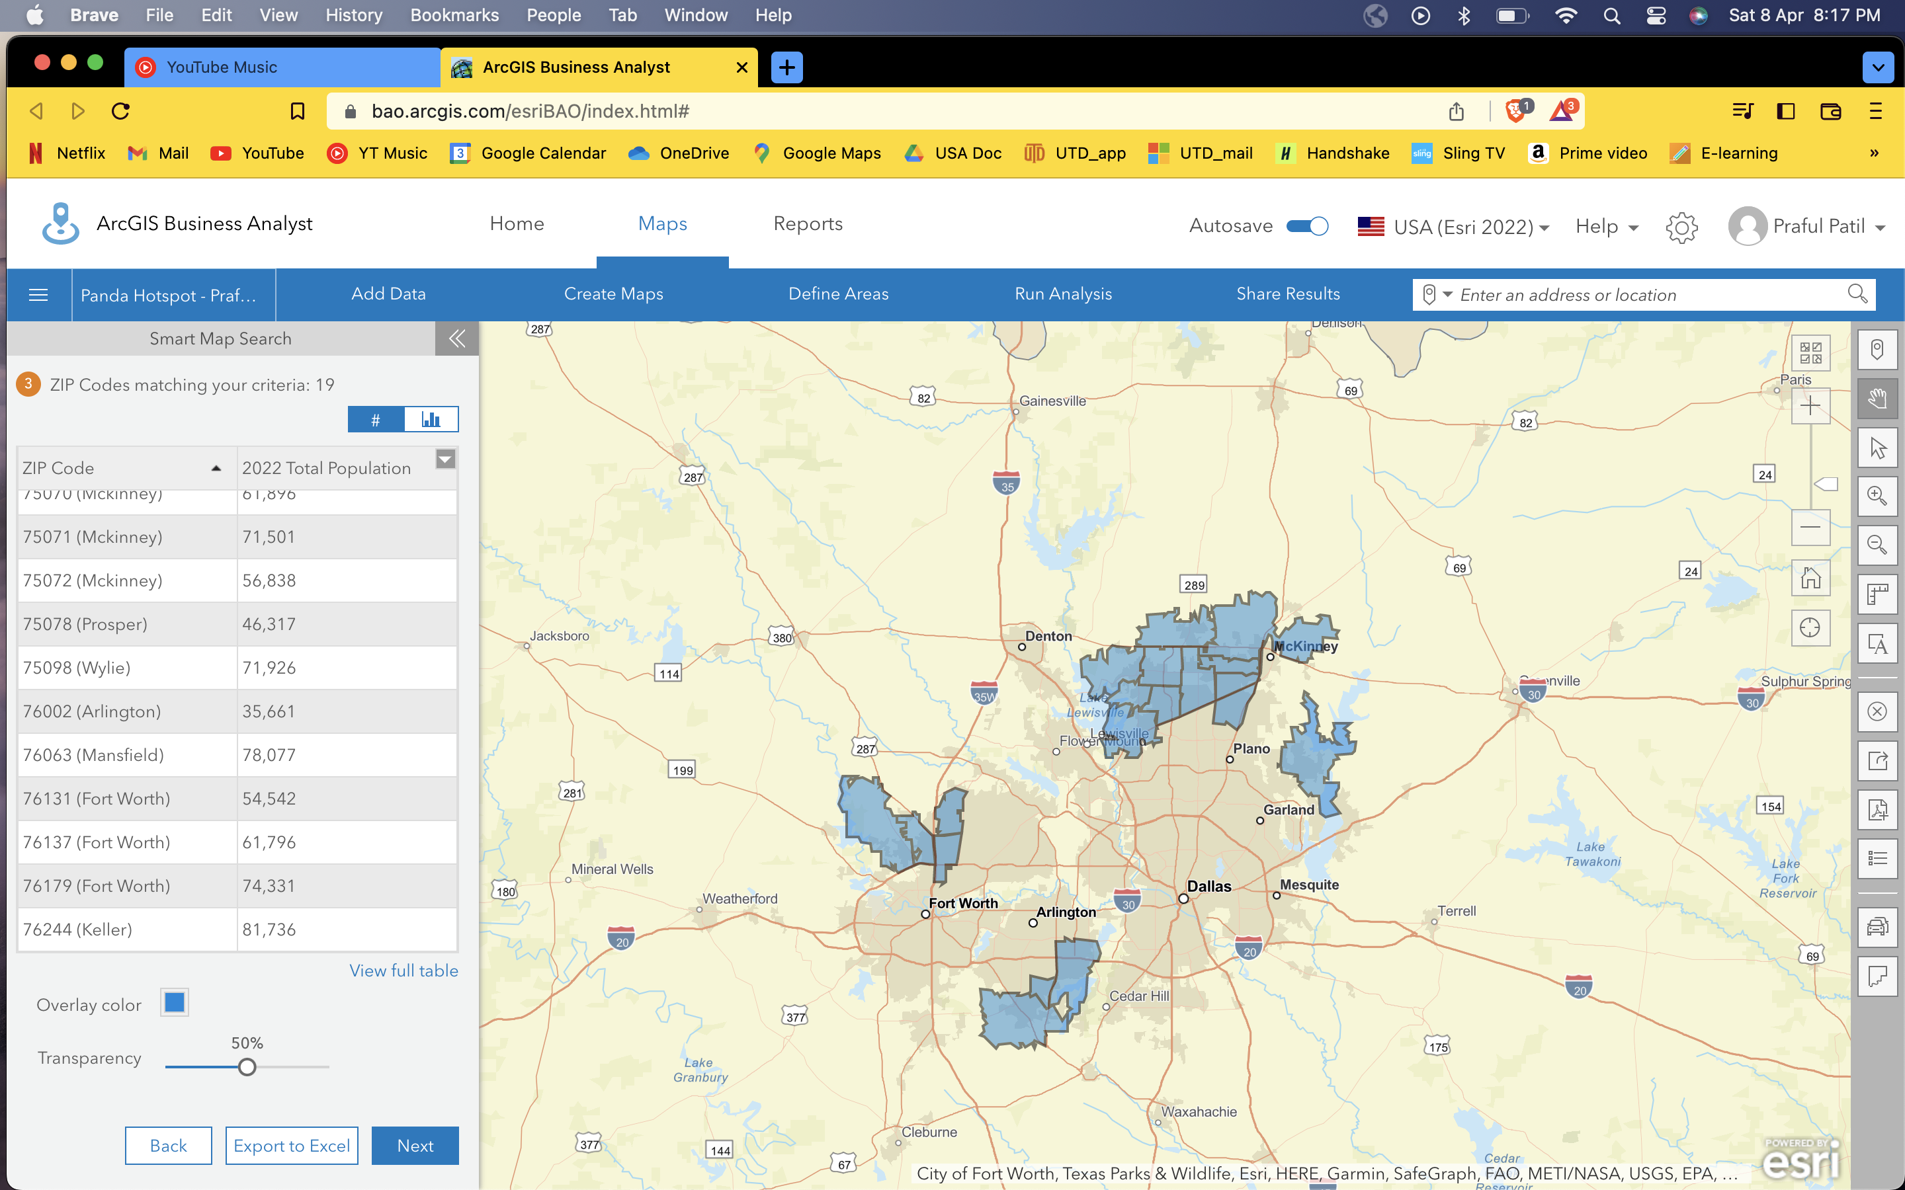

**Q12**

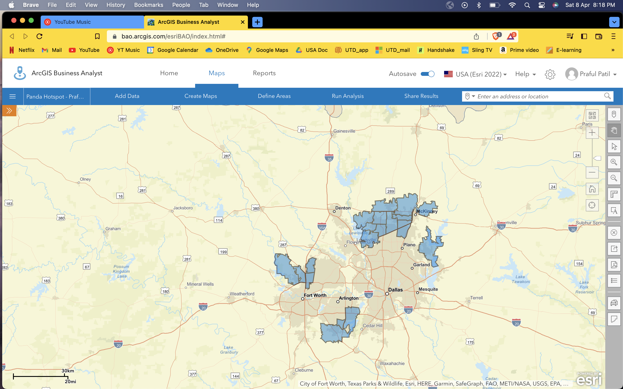

**Q13**

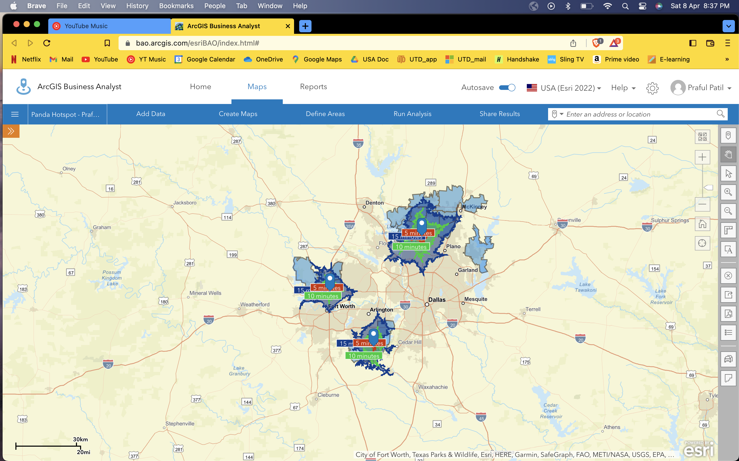

**Q14**

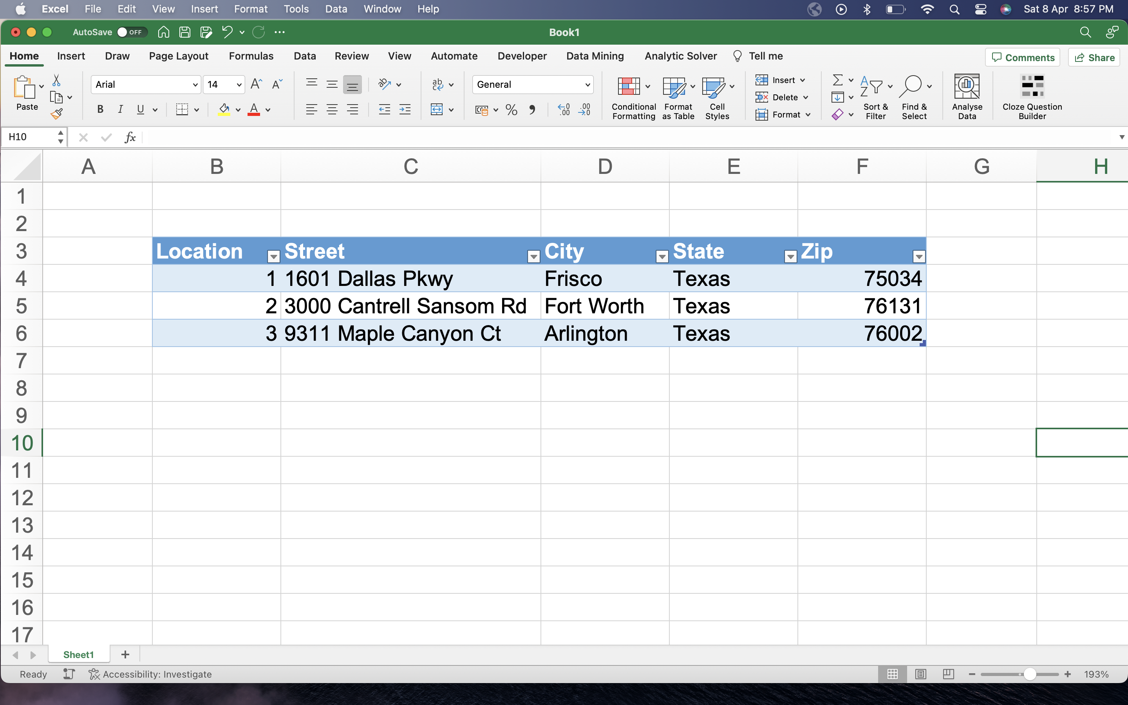

**Q15**

Location 1:

X: -96.823291 Y: 33.092737

Location 2:

X: -97.31561 Y: 32.845221

Location 3:

X: -97.081106 Y: 32.596164

**Q16**

